**Institutional Market Structure**

Inside Price Action: Institutional Market Structure

What Is Institutional Market Structure?

The analysis of correlated assets or the relationship to inversely correlated assets. The purpose is to determine what the "Smart Money" is accumulating or distributing. Currencies are easy to analyze with Institutional Market Structure with the USDX. Every price swing should be studied to determine if Market Symmetry confirms it.

How Do We Identify Institutional Market Structure In Forex?

Compare every price swing in the USDX with the Foreign Currency you trade. As USDX trades Higher, expect a Lower price swing in Foreign Currency pairs.

If USDX or a Foreign Currency fails to move symmetrically- Smart Money is actively trading. As USDX trades Lower, expect a Higher price swing in Foreign Currency pairs.

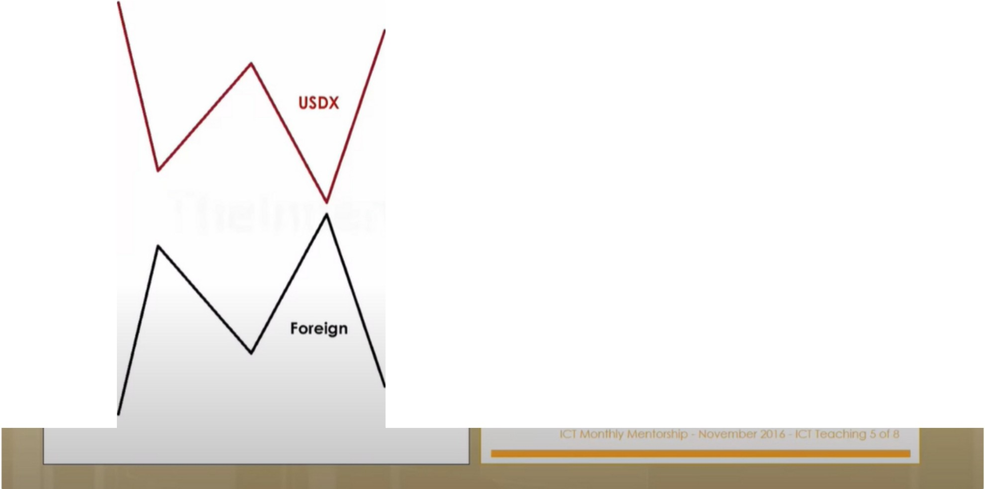

If USDX or a Foreign Currency fails to move symmetrically - Smart Money is actively trading.

**In titutional Mark t Structur**

...

, ("

In Symmetrical Market conditions:

**When the USDX makes a lower low; Foreign Currency makes a higher high.**

This confirms current price action and the underlying "trend" is likely to continue.

**The idea of stalking reversal patterns in this condition is not high probability and should be avoided.**



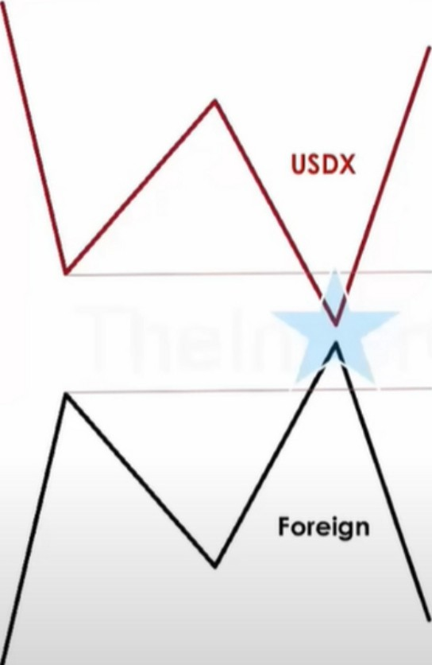When this happens, the trend will likely continue bullish



**nst tutional Market Structur**

In Symmetrical Market conditions:

**When the USDX makes a lower low; Foreign Currency makes a higher high.**

This confirms current price action and the underlying "trend" is likely to continue.

**The idea of stalking reversal patterns in this condition is not high probability and should be avoided.**

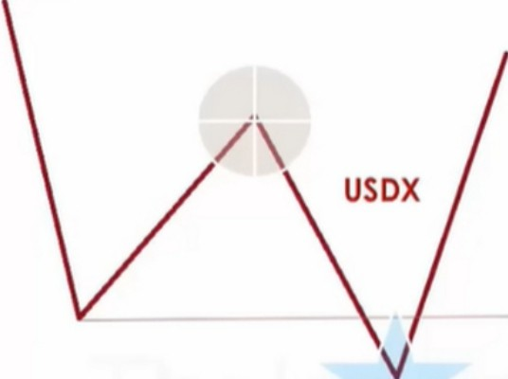

'-,*I*/ **Foreign**



**In titutional Mark t Structure**

In Symmetrical Market conditions:

**When the USDX makes a lower low; Foreign Currency makes a higher high.**

This confirms current price action and the underlying "trend" is likely to continue.

**The idea of stalking reversal patterns in this condition is not high probability and should be avoided.**

I' -

**r---.**

This is 1 of the ways we can anticipate a turtle soup will happen before it actually happens



**Institutional Market Structur**

In Symmetrical Market conditions:

**When the USDX makes a higher high; Foreign Currency makes a lower low.**

This confirms current price action and the underlying "trend" is likely to continue.

**The idea of stalking reversal patterns in this condition is not high probability and should be avoided.**

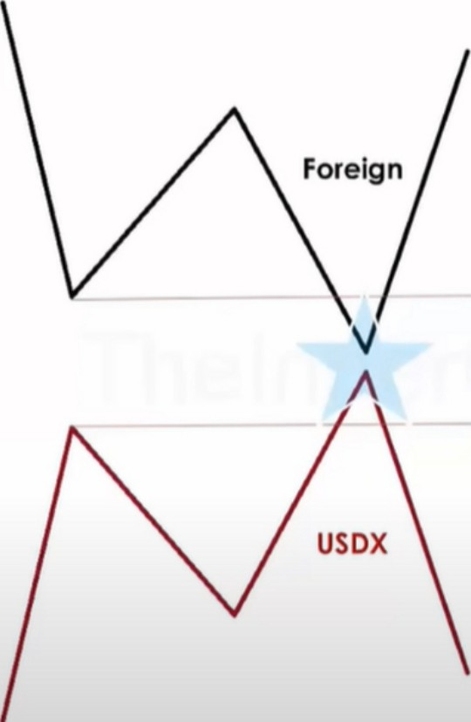Same goes for when the currency is bearish

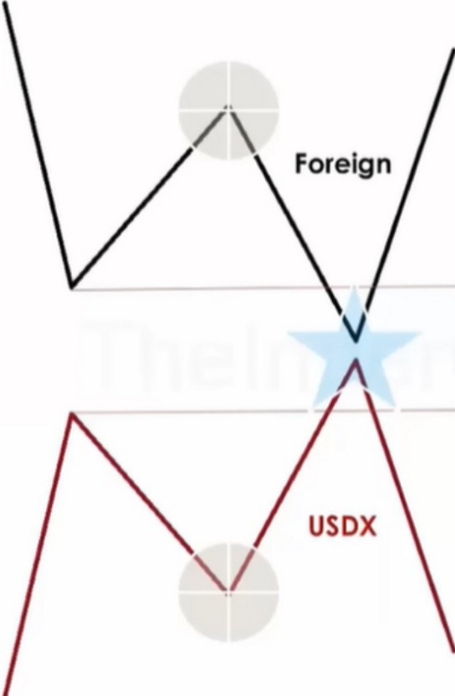

**In tltutional Mark t Structure**

In Symmetrical Market conditions:

**When the USDX makes a higher high; Foreign Currency makes a lower low.**

This confirms current price action and the underlying "trend" is likely to continue.

**The idea of stalking reversal patterns in this condition is not high probability and should be avoided.**

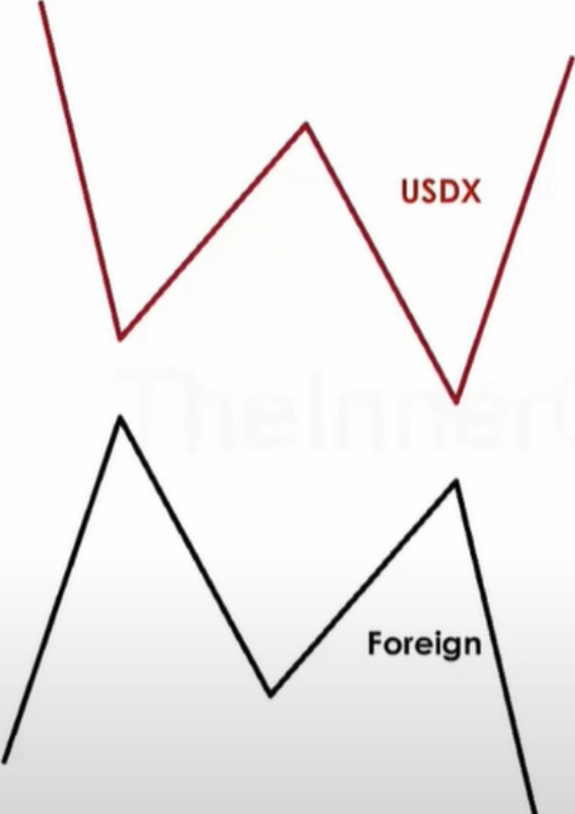

This is likely indicating a reversal



**In titutional Mark t Structur**

In Non-Symmetrical Market conditions:

**When the USDX makes a lower low;**

**Foreign Currency fails to trade higher than a previous high** - **this is USDX SMT.**

# This does not confirm current price action and the underlying "trend" is likely not to continue.

**The idea of stalking reversal patterns in this condition is high probability** & **could reasonably be considered.**



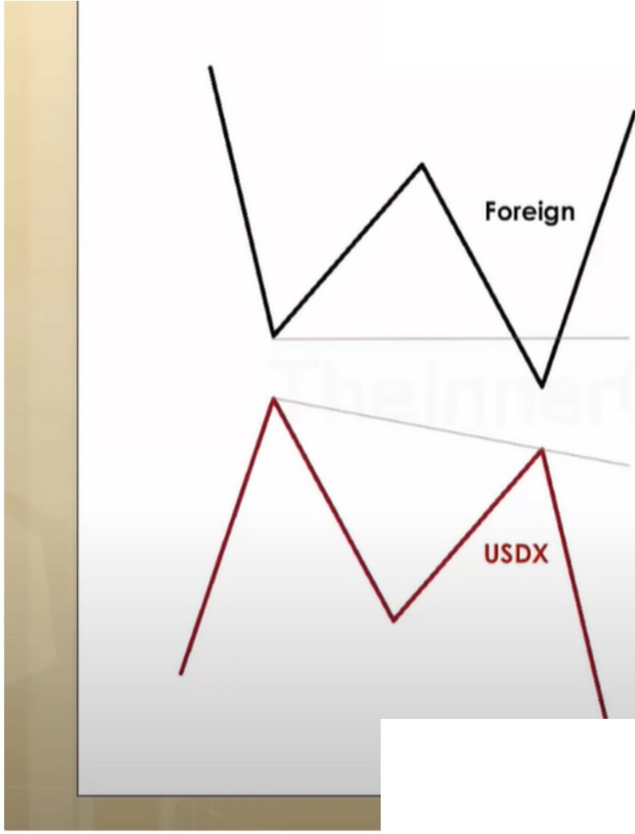

**In t tutional Market Structure**

In Non-Symmetrical Market conditions:

**When USDX fails to make a higher high; Foreign Currency makes a lower low.**

This does not confirm current price action and the underlying "trend" is not likely to continue.

**The idea of stalking reversal patterns in this condition is high probability** & **could reasonably be considered.**

' t -

**r----·**

SMT divergence

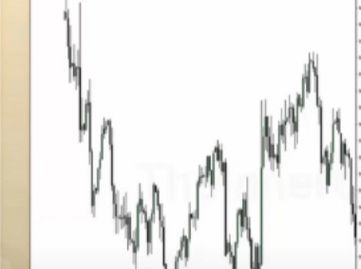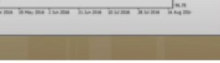

**lnslftulfonal Market Structure**

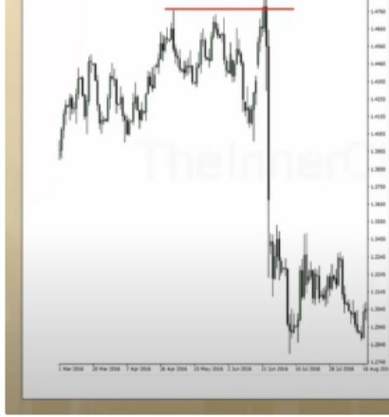

**lnstltulfonal Market Structure**

This will tell us that on USDX theyre accumulating orders on the long side. So we will be bullish on

the dollar, bearish on GBP

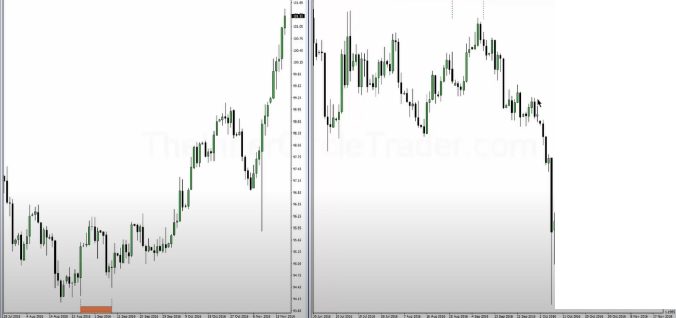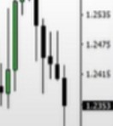

***a***

·**U**­**fll**

·-

·1

l1lH 11

::

USDX is accumulating and GBPUSD is distributing, and GBPUSD is a turtle soup

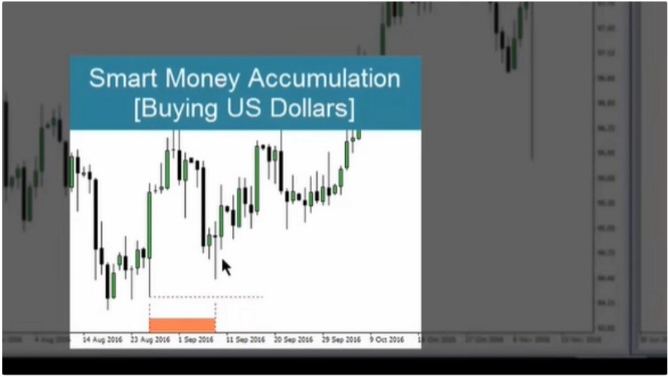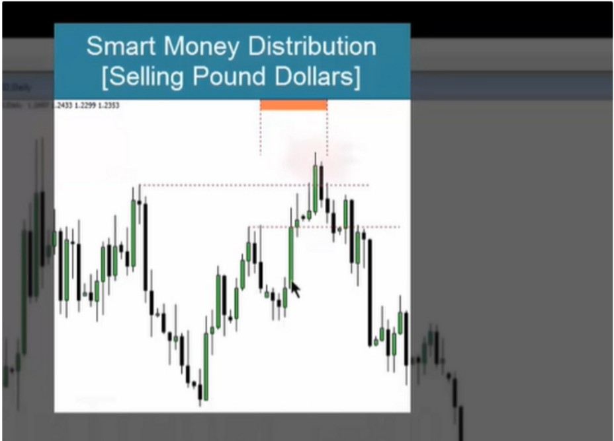

This will give you a long/intermediate term bias, because this is on the daily timeframe

**Smart Money Action Plan**

**Buy USD/ Pairs Sell /USO Pairs**

# Arjo I Twitter, lnstagram I Linktree

Linktree. Make your link do more.

1 https://t.co/HhmmTN1fUI

# JavaScript is not available.

*"'JI* https://twitter.com/arjoio